Maze Solving Robot Assignment

  - ME30295: Electronics, Signals and Drives
Harry Mills: 12245

Summary
This report details the process of writing and testing code to drive a maze solving robot. A Lego Mindstorms NXT robot programmed with RobotC code was used in this assignment. Light sensors pointing at the floor allowed the robot to follow a black line to not hit the walls of the maze, while ultrasonic distance sensors on the front and left of the robot detected the presence (or lack of) walls in the maze at certain points.
A program was successfully written that used the left-hand rule (i.e.: turn left whenever possible) to autonomously drive the robot from the start to the finish of the maze. Furthermore, using the recorded left-hand rule path, the shortest return route to the start of the maze can be calculated. This has been implemented in pseudo-code as an example of how this would be completed. The shortest return route is calculated by using an algorithm to simplify the recorded route until it can no longer be simplified; at which point the shortest return route has been calculated.
Contents
Summary i
1. Introduction 1
1.1. Assumptions 1
2. Conclusion 2

Introduction
This report details the writing and testing of code to solve a maze using a Lego Mindstorms NXT robot. Any 2D maze can be solved using the left-hand rule and it is very simple algorithm to implement; if you can turn left, turn left.
Also described in this report is the method for calculating the shortest return path through the maze after reaching the finish via the left-hand rule. This was done using an iterative algorithm which removes redundancies in the recorded robot path until it can be simplified no further.

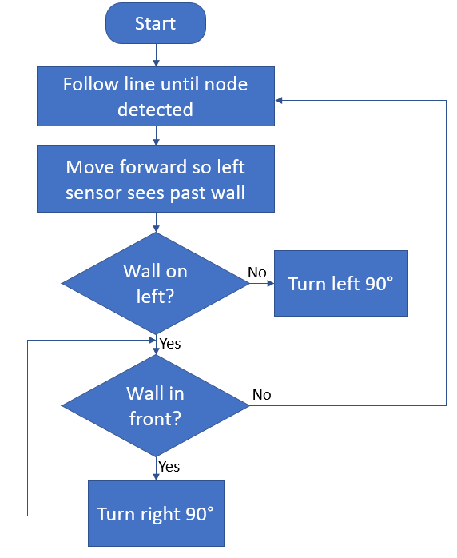
Maze Solving Task
Figure 1 Flow diagram for solving a maze using the left-hand rule

Conclusion
The Maxon-Parvalux EPM63-100 has been shown to be a suitable motor for this application. This was done by firstly making a set of initial assumptions and then using these, along with provided data, to perform the necessary calculations and analysis to confirm this motor could meet the requirements of the system. The motor will be coupled with a 2-stage belt and pulley transmission with an overall ratio of 21.77. Motor control according to the calculated velocity profiles will be provided by the Maxon-ESCON 70/10 converter.
After initially selecting the motor, it was checked for suitability by comparing the rated peak and r.m.s torques against the predicted demanded torque values from the belt conveyor. The next size down in the Maxon motor range was similarly checked (EPM63-75) and this was confirmed to be too small for the application, meaning EPM63-100 is the motor that should be used.
Finally, optimisations to the system were analysed. Firstly, shortening the acceleration and deceleration phases was considered using an iterative spreadsheet to find the respective shortest times that kept the peak torque within allowable limits. This yielded a faster cycle time of 3.8 seconds. Next, the effect of implementing ‘filling on the move’ was investigated. Optimising the acceleration and deceleration phases of the velocity profile as before, it was possible to shorten the cycle time to 3.54 and 3.29 seconds for filling at 10 % and 20 % of the maximum speed respectively.

